Embedded Systems

# Density Based Traffic Light Control System

# Image result for un sustainable development goals 9

# Objective:

To build a density based traffic control system.

Traffic is a huge problem in almost every metropolitan city in the world. Getting stuck in traffic wastes time, energy, resources and is also harmful to the environment. Traffic lights play a crucial role in regulating traffic on roads. Thus, it becomes necessary to control the delay time of traffic lights. A density based traffic control system is a good way to mitigate the issue.

This project aligns with the 9th sustainable development goal put forward by the UN, ‘Industry, Innovation and Infrastructure’.

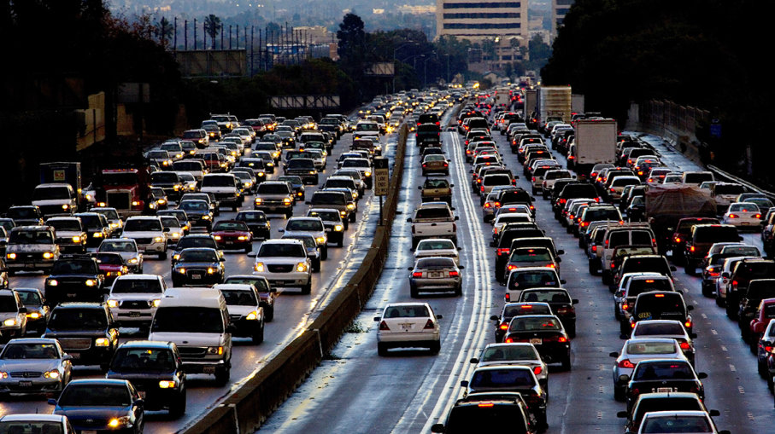

# System Requirements:

In this system, IR sensors are used to measure the traffic density. One IR sensor is arranged for every road and their function is to sense traffic flow on that road. All of the sensors are interfaced to the microcontroller. Based on the input received, the controller will detect and control the traffic flow.

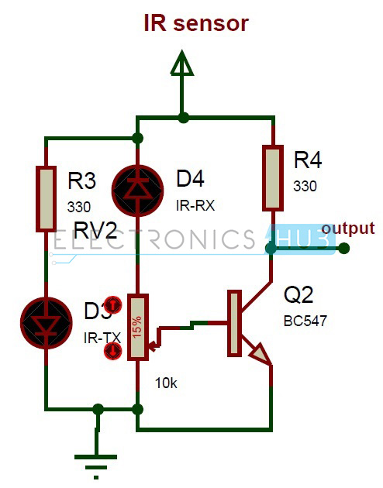

The IR sensors are mainly composed of two parts; a transmitter and a receiver. The transmitter is made from GaAS and emits only infrared waves.

The current supplied to the circuit depends on the maximum distance the circuit is designed to operate for. We have to place these IR pairs in such a way that when an obstacle passes between it, it is detected. When a car passes between the transmitter and the receiver, it blocks the IR rays and as a result the resistance of the photodiode increases. This change in resistance can be converted to electrical pulses used to control traffic lights.

# Circuit:

Components:

* AT mega8 controller
* PCB board
* IR sensors – 4
* LED’s – 12 ( 4 red, 4 green, 4 yellow)
* 12V battery or adaptor
* Serial cable
* Connecting wires

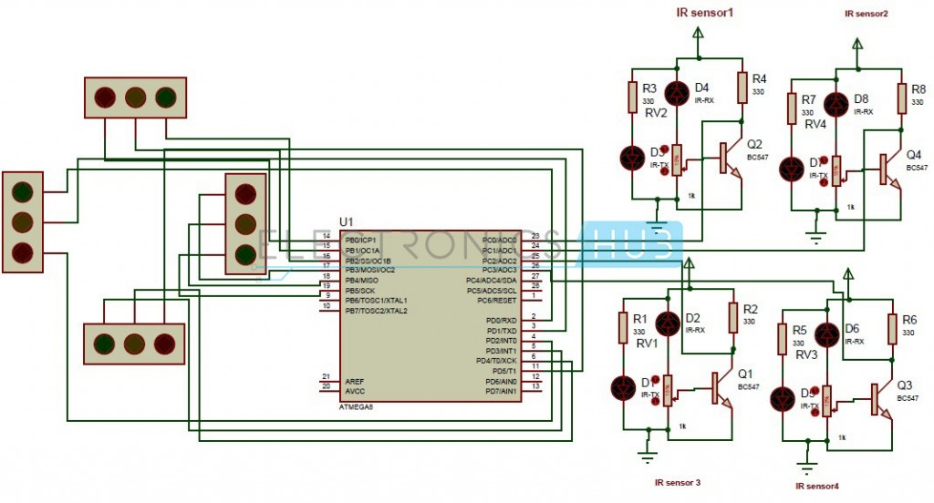

Working:

The circuit here is designed to be implemented on a junction. It consists of 4 IR sensors, atmega8 microcontroller and 4 traffic lights. The IR transmitter operates under 2-3V and emits IR rays which are invisible to the human eye. The IR receiver receives IR rays that are sent from the transmitter. When power is supplied, the transmitted IR rays hit the object and reflect back to the IR receiver. Normally the receiver has high resistance in order of mega ohms. When it is receiving IR rays the resistance is very low. The operating voltage of IR receiver is also 2-3V. IR sensors are connected to the PORT C (PC0, PC1, PC2, PC3) of the microcontroller and traffic lights are connected to PORT B and PORT D. If the density of traffic on the road is high then that particular sensor output becomes logic signal 0 and otherwise is at 1. If logic signal 0 is received, i.e. high density, then the green signal is given to that particular traffic light and all others become red.

Logic Flowchart:

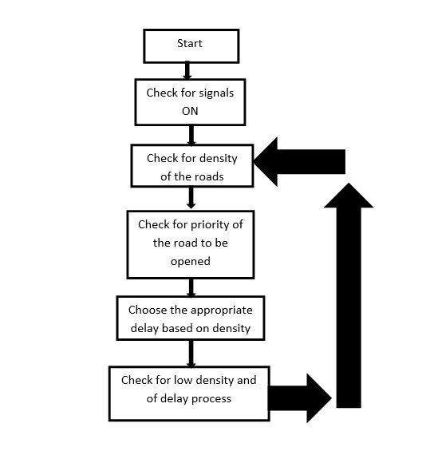

# Program Code:

To program Density Based Traffic Light Control System first the necessary header files are included and the input and output pins are initialized.

#define F_CPU 8000000UL

#include <avr/io.h>

#include <util/delay.h>

#define R1 PB0

#define Y1 PB1

#define G1 PB2

#define R2 PB3

#define Y2 PB4

#define G2 PB5

#define R3 PD5

#define Y3 PD4

#define G3 PD3

#define R4 PD2

#define Y4 PD1

#define G4 PD0

int main(void)

{

DDRB = 0xff;

DDRD = 0xff;

DDRC = 0x00;

PORTB = 0x00;

PORTD = 0x00;

   while(1)

   {

if((PINC&0x01) == 0x01)

{

PORTB |= (1<<G1);

PORTB |= (1<<Y2);

PORTD |= (1<<R3);

PORTD |= (1<<R4);

}

else if((PINC&0x02) == 0x02)

{

PORTB |= (1<<R1);

PORTB |= (1<<G2);

PORTD |= (1<<Y3);

PORTD |= (1<<R4);

}

else if((PINC&0x04) == 0x04)

{

PORTB |= (1<<R1);

PORTB |= (1<<R2);

PORTD |= (1<<G3);

PORTD |= (1<<Y4);

}

else if((PINC&0x08) == 0x08)

{

PORTB |= (1<<Y1);

PORTB |= (1<<R2);

PORTD |= (1<<R3);

PORTD |= (1<<G4);

}

else

{

PORTB = 0x00;

PORTD = 0x00;

PORTB |= (1<<G1);

PORTB |= (1<<Y2);

PORTD |= (1<<R3);

PORTD |= (1<<R4);

_delay_ms(7000);

PORTB = 0x00;

PORTD = 0x00;

PORTB |= (1<<R1);

PORTB |= (1<<G2);

PORTD |= (1<<Y3);

PORTD |= (1<<R4);

_delay_ms(7000);

PORTB = 0x00;

PORTD = 0x00;

PORTB |= (1<<R1);

PORTB |= (1<<R2);

PORTD |= (1<<G3);

PORTD |= (1<<Y4);

_delay_ms(7000);

PORTB = 0x00;

PORTD = 0x00;

PORTB |= (1<<Y1);

PORTB |= (1<<R2);

PORTD |= (1<<R3);

PORTD |= (1<<G4);

_delay_ms(7000);

PORTB = 0x00;

PORTD = 0x00;

}

   }

}

# Limitations:

* The IR sensors may cause disruption to traffic system by absorbing normal light sometimes.
* IR sensors can operate through small distances only.
* The sensors must be arranged appropriately, otherwise it may not detect the traffic density properly.